Career Research Project
Course:
Professor:
Date:
Introduction
In my career choice, I intend to choose a dentistry degree as my major in Kentucky University. In my career, I want to put a lot of effort in my course work first which will enable me to get good results that will give the opportunity to secure a good future in my career. I understand my career choice needs a lot of attention. I expect to secure an independent work where I will be able to create my client base and work towards establishing my business where I will be able to earn the salary that I want I expect my business to break even within its first year of establishment. My salary expectations for my business will be on revenue basis and I expect to make over $120,000 within the first year of business. After paying my workers and deducting expenses, I expect to make a substantive amount of not less than $3,000 per month within the same period. However, this establishment will need a humble beginning to establish, the facility will need equipment such as X-ray machines, lasers, digital scanners, probes, forceps, scalpels, mouth mirrors and other computer technologies, which will need a higher capital for start-up.
Research of College/university
Overview of selected school (Characteristics)
Kentucky University demographic information entails include students and staff of different ages, nationalities, sexual identities, religions, races and social classes. Ethnically diverse situation in the school ensures that all students meet and learn from different racial and ethnic backgrounds. The following is a detailed information about the school’s diversity.
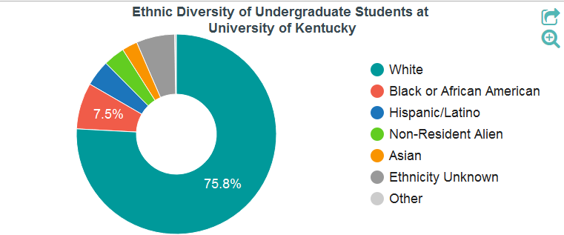
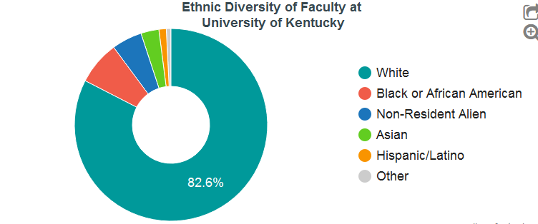
The university operates satellite campus in Paducah located in West Kentucky community. It also has campuses in Eastern and North Kentucky.
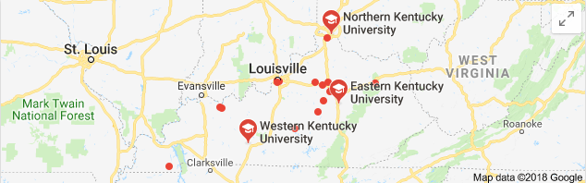
Other characteristics of Kentucky University include;
- The university adapts and takes care of the student needs today
- The university embraces technology. E.g. in equipment and network. For example, the school has online libraries and other technological facilities such as labs.
- It forges partnerships with other institutions
- It keeps a figure in the job market and provides services in line with the market demand. The course work prepares the students for market jobs and in return employ staff that is qualified to teach the students.
Course of study
My selected school is Kentucky University, which is a good school that I am, sure will improve my dentist career to a notch higher. The required minimum GPA in the school in order to successfully accomplish my schoolwork and graduate is 2.0 out of a possible 4.0. According to University of Kentucky, it needs applicants who are well educated in sciences as well as liberal arts for admission. According to Kentucky health curriculum where dentistry lies, it highly focuses on the pursued student desire. The prerequisite course work is taken for a grade option and not a pass and fail situation. The applicants are advised to pursue a well-rounded curriculum that includes both humanities and sciences. Courses that the student will be expected to pursue in the dental career are not limited to;
- Humanity
- Immunology
- Genetics
- Biology
- Physiology, cell biology among others
Please see the attached dentistry curriculum guide in Kentucky University (See Appendix I)
Educational expenses
The degree is costly but I intent to make my payments in installments through the support of my parents, friends, and any other parties interested in my career. I plan to ensure that I utilize all the money paid form for my career by taking the program seriously. To achieve my educational goal, it will take me the recommend 4 years of study work and maybe a one or two years out of school to establish myself, do some on-job training and later on venture into my own business. The cost of my degree include an admission non-refundable fee of $250 for non-residents and $1,000 for out of state applicants. The fees is as follows;
Upper Division Non-Resident‎: ‎$13,256.00
Upper Division Resident‎: ‎$5,823.00
Lower Division Non-Resident‎: ‎$13,078.00
Lower Division Resident‎: ‎$5,660.00
Career Research
Career research outlook
The expected availability of jobs in my dentistry career it seems that the market is not yet fully saturated. There are new jobs every day however most of the well-paying jobs in the market requires a much higher experience that I lack as of now. It is a career that needs growth from one level to the other. The self-employed in market, however, are doing so well where I intend to go
The nature of working conditions include giving clients tooth care services such as refiling, shaping and more. The operating hours for the self-employed are not strict and accommodate the clients need. There is minimal travelling in the work since it is in-office duty. The working environment is friendly with little noise.
Training and education are key in this program. Every practitioner needs knowledge on how to do it and help the clients in improving their tooth health. Certification and training licenses are needed to act as proof of qualification. Most of the work is done using technological equipment making it efficient.
The earnings depend with the career qualifications, experience and the facility one is working in. well paid practitioners are experienced and learned. The expected salary in employment average $3,000/m for start-up and $10,000 for well-established individuals. It is paying the same as other medical careers such as Registered Nurse.
I like the career because it has minimal movements and the working environment is ample. This makes the career interesting and well paying to individuals who are not faint hearted. It only needs a little patience.
Interview summary
I have learned that I need to take my career with a lot of seriousness in order to change my life and the people in the society. The career has many openings and as long as one is qualified, there is no need to worry. From the interview, I have learned that I have a lot to do and make the society a healthy place to live.
Self-assessment questions.
I received information that this career needs patience for it to pay and that it is well paying once one is experienced. However, I was distressed by the fact that there is more that needs to be done in the career in order to ensure that clients get good services that matches the money paid. The most useful thing I have learned is that the career needs patience to pay well. I am interested in pursuing the career.
Summary
I have learned that the dentistry career is a good career that one can specialize on. I am interested in career and my personality matches the career framework. I am always eager to help someone out of a problem and I think this will help me do a good work. This paper has changed my views and thoughts about the dentistry career and what I need to do to make it in the career.

Works Cited
Bernstein, A. B., Schaffzin, N. R., & Princeton Review (Firm). (2013). Guide to your career. New York: Random House
Brooks, J. (2015). How to develop your career in dentistry.
Harrison, L. H. (2017). Western Kentucky University.
Institute, . C. R. (2016). Careers in Dentistry. Createspace Independent Publishing Platform.
Institute for Career Research. (2015). Career as a dentist: Doctors specializing in oral healthcare. Chicago, Ill.: Institute for Career Research.
Rennick, R. M. (2016). Kentucky place names. Lexington, Ky: University Press of Kentucky.
Tenkotte, P. A., & Claypool, J. C. (2015). The encyclopedia of northern Kentucky. Lexington: University Press of Kentucky.

APPENDIX I
